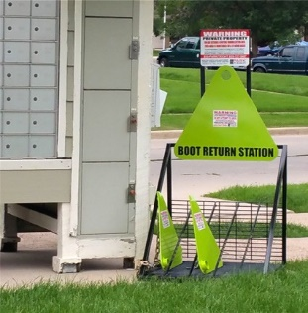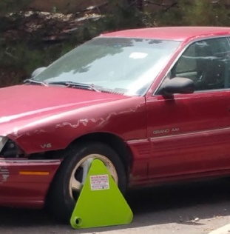

**Saves Time and Money**

If you happen to find that you have been booted you are able to call the phone number on the boot or driver’s window 24/7. Our call center will provide you with several options to release the boot.

**Remote Release**

Allows you to be on your way in minutes this option. You call in, pay your boot fee and a boot deposit we will then give you the code to release the boot and where to return the boot.

**Small Boot - $135.00 Medium Boot (SUV) - $150.00 Deposit - $250.00**

**Onsite Release**

If you don’t have a credit card our onsite release can be performed 24/7 as well.

**Small Boot - $185.00 Medium Boot (SUV) - $200.00 After Hours - $50.00 Additional**

**Boot Return Station**

In conjunction with our Remote Release Boot System, we developed a Boot Return Station, which provides a location where the boot can be returned without waiting for an office to open.

**Remote Release Booting**

Park it Right’s patent pending Remote Release Boot System provides a less expensive alternative to towing. Our system eliminates most contact with property managers concerning parking problems. Once a boot is placed on a vehicle, a violator can call our 24/7 Customer Service Center and pay their boot fee. Once the fee is paid along with a deposit, the boot is released and the vehicle is freed up to resume usage within minutes.

**Education**

Our system begins with education at the property. We provide you with Parking Rules for inclusion in your lease documents as well as information for your newsletters or bulletin boards. We supply clear signage in your parking areas and on our boot return stations. These techniques limit the excuse of “no one ever told me” for parking violations.

**How it works**

**Parking Enforcement**

Parking Enforcement consistently ranks as one of the biggest headaches for tenants, guests and management of a multi-family community. Park it Right uses a technology driven approach that is focused on education and enforcement to solve this frustrating problem. Proper parking management takes more than a Tow Away warning sign. To eliminate parking issues for communities you need Park It Right’s “No Tow Solution”.

**855-727-548**[**7 • www**](http://www.parkitright.net/)**.parkitright.net • Park It Right, Inc.**